Geomorphology (Geology)

Pre-Lesson One
River Continuum Concept & Watershed Development

Student Outcomes:
Students will:
- Understand the properties of a natural system
- Break down a river system into its primary components
- Discuss the importance of feedback loops and dynamic equilibrium

Purpose:
- To develop the concept of systems as a way to analyze and understand the form, function, and interconnectedness of nature.
- To examine a river as a system balanced by interactions among its main components

Materials/Resources:
- White boards and dry-erase markers

Background information:
Our planet consists of many complex, large-scale, interacting systems. A system is a network of relationships among a group of parts, elements, or components that interact with and influence one another through the exchange of energy, matter, and/or information. A system receives input (energy, matter, info), processes or interact with this input and responds with an output. This exchange drives a feedback loop, or circular process whereby a system’s output serves as input to that same system. The components in a system interact with each other within feedback loops.
In a negative feedback loop, the output acts as an input that moves the system in the opposite direction. This compensation stabilizes the system. For example, when your brain processes an input that you are too warm, its output is too get cooler by removing a jacket or turning on the air conditioner. As you get cooler, you brain processes this new input and outputs a response to turn off the air conditioner. As a result of this opposite input vs. output, or negative feedback loop, your body system stays at a stable temperature. This alternating give-and-take cycle, or dynamic equilibrium, functions to keep a system within a healthy range. Processes in the system move in opposite directions at equivalent rates so their effects balance out. The progression of dynamic equilibrium acts to stabilize a system when it is disturbed by external forces.
In a positive feedback loop, the output acts as an input that moves the system further in the same direction as the initial input. This magnification of effects destabilizes the system. For example, a desert environment can act as a system. The system’s components in this case are the living organisms. If there are no predators in this desert, such as coyotes and mountain lions, then jackrabbits can reproduce and there is no stopping their increase in population. The input to the desert system is more jackrabbits. Each new generation of jackrabbits can then reproduce again, increasing the overall population because the desert system void of predators responds to the new generation by allowing even more jackrabbits to survive. As a result, the number of jackrabbits will increase until another component of the desert system breaks down, such as rabbit food sources, preventing other animals to eat and survive, at which time the desert system is destabilized. The predator component had been altered in this desert system leading to a breakdown of the system as a whole. Predominantly, natural systems experience a positive feedback loop due to human impacts, including over-hunting of predator species.
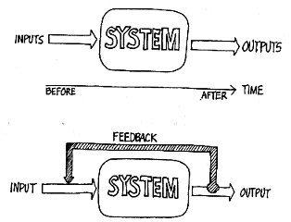

It is important to note that humans define system boundaries for simplicity and understanding. In reality, there are no boundaries defining systems; all systems serve as components in another larger system. In our case, we will look at the Beaver Creek watershed as a system, however we must keep in mind that inputs from outside the watershed such as precipitation and solar radiation affect the components of the system.

The River Continuum Concept was developed by Robin Vannote et al. in 1980. The concept was revolutionary in aquatic ecology because it was the first time biologists stepped back from studying a tiny portion of a river or creek and looked at rivers as a watershed-scale system. This new perspective allowed Vannote and his fellow researchers to see new patterns and connections between the various components of a river system. These components include the chemical, biological, and physical or geologic/geomorphic elements of a watershed. In the past, each of these components was studied independently. Now, studying the interactions among these components reveals properties of watersheds that were previously unknown. Such properties, referred to as emergent properties, are evident at the system level, but remain elusive when investigating individual components of a system. Today, scientists are discovering emergent properties that explain how aquatic organisms respond to changes in the physical and chemical components of a watershed. These discoveries answer questions about how and why aquatic organisms disperse themselves in creeks and rivers.
(Unique to Geomorphology Module) In order to comprehend how all these discoveries developed, we must first recognize what defines a watershed. A watershed begins with a small flow of water, typical of areas along the Mogollon Rim in northern Arizona. These small trickles converge to form consecutively larger streams which gain flow. The increase in flow leads to wider and deeper channels downstream from the headwaters. Therefore, streams at lower elevation in the watershed will carry more water in deeper, wider channels than streams higher in the watershed. The River Continuum Concept is based on this pattern of progressive physical change established by manner water travels down a watershed. The changes include an increase in stream size and flow discharge, a decrease in shading as the channel widens, and a decrease in sediment size along the channel bed.
The geology of the watershed controls these changes. Uplifted regions such as mountain ranges or plateaus serve as the headwaters of watersheds where streams are straight and narrow, soils are thin, and streambeds are primarily rocky with little sediment. As streams flow, they gains size and power, eroding sediment and flattening out. A continuum of physical environments exists down a watershed from high elevation headwaters to wide, sediment choked, river valleys. Accordingly, organisms must migrate to the habitat that suits them best within this physical continuum.

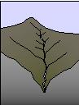  High Elevation | 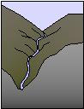  Transition Zone | 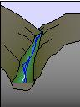  Transition Zone | 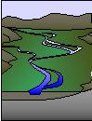  Valley
http://www.fish.washington.edu/naturemapping/water/1wtrshd.html

The main functions of a river system include transporting sediment, dissolved solids and gasses (e.g. Mg, Ca, Na, O₂, CO₂), organic matter, and nutrients. Sediment weathers out of the watershed geology. Dissolved solids come from the watershed geology, groundwater, and human activities. Dissolved gasses are produced by aquatic photosynthesis (O₂) and respiration (CO₂). Organic matter is created within a river by photosynthetic organisms (e.g. algae, water lilies) and enters from outside the river (e.g. fallen leaves). Nutrients, specifically nitrogen and phosphorus, are contained within organic matter and dissolved in the water.
A river’s biological community adjusts to changes in form (primarily controlled by sediment transport) and function of the river system in order to effectively use the energy (organic matter/nutrients) provided by the watershed. Organisms process the organic matter, utilizing a certain amount and passing the remainder downstream where other organisms repeat the cycle. Thus, the biological component adapts to changes in the chemical and physical components to maintain a dynamic equilibrium within a river system. For example, if a large flood travels through a watershed, river channels may change shape and orientation as sediment is eroded from some areas and deposited in others. In addition, organic matter and dissolved nutrients will be carried to various locations downstream. As a result, aquatic organisms will move to new habitats that have formed in the modified river channel in order to fulfill their niches – an organism’s functional role in a system. In this way, changes in the physical and chemical components of the river caused by the flood lead to adjustments by the biological component, preserving the equilibrium of the river system.

Key characteristics of systems:
- Systems consist of interacting components.
- Synergies among system components create a whole that is more than the sum of its parts (emergent properties) – a key reason the river continuum concept was revolutionary.
- System boundaries are artificial: systems are components of another larger system.
- Systems have inputs, processes/interactions, outputs, and feedback loops.

Procedure:
Write down an example of a negative and a positive feedback loop system.
- What are the components?
- What is the output?
- What is the outcome of the loop?

Create a flow chart: Make a chart based on the example of a natural system with a feedback loop:
- Feedback systems in science. Choose one of the following to draw a flowchart on a poster board or come up with your own negative feedback system in science. Be prepared to explain the benefits of having negative feedback systems.
  - o Feeling of hunger or thirst
  - o Human body temperature
                - o The regulation of glucose in our bodies (Diabetes is a disease in which part of
                - the feedback loop doesn't function properly due to a lack of the hormone insulin.)

Assessment:
1. Mr. Carter is a butcher. He has sliced off the end of his finger. As blood poured out of the finger, his blood pressure dropped. His heart pumped faster to restore normal blood pressure. What effect would this response have on Mr. Carter's stability? How would this be an example of a negative feedback loop?

2. At a town meeting in Alaska, a biologist explained the population growth of wolves as follows: "Like all species, the population growth of wolves is regulated by positive and negative feedback loops. When the wolves were re-introduced, a positive feedback loop was present. Over time, the population stabilized due to a negative feedback loop." What is this biologist talking about? In addition to the wolves’ population, think about changes in the populations of their prey.

Pre-Lesson Two
River morphology

Student Outcomes:
Students will:
- Identify various river morphologies
- Explore the dynamics that shape the physical component of a watershed
- Develop questions and hypotheses for physical changes in the Beaver Creek and Verde River watersheds.

Purpose:
- To establish the role that river geomorphology plays as the physical component of the River Continuum Concept
- Understand what drives the dynamic nature of the structural (physical) framework through which a river flows

Materials:
- Aerial photos of various river morphologies including the Beaver Creek watershed (Beaver Creek website: http://www.mpcer.nau.edu/beavercreek/)
- http://terraserver-usa.com

Background information:
As we learned in the last lesson, the channel shape or morphology of a river changes in response to diverse geologic conditions along the river continuum. Primarily the slope of the landscape, or gradient, and the amount and size of sediment carried by the river, or sediment load, controls the channel morphology. In general, faster flowing water (flow velocity) can pick up and carry more and larger size sediment, as long as available sediment exists. When velocity slows, sediment drops out of the flow and is deposited. The three main morphology types include straight, meandering, and braided. Each morphology type defines the physical conditions within the river continuum, establishing diverse habitats for aquatic organisms.
Straight channels are rare and generally only appear for a short distance in steep, mountainous headwaters at the top of a watershed before the river channel begins to meander. The direction of flow is strongly controlled by the steep terrain, causing the straight morphology. Although the steep gradients generate faster flow velocities, the channel walls, often cut into bedrock, provide little sediment. Therefore, straight channels are frequently clear, fast moving, narrow, shaded streams.

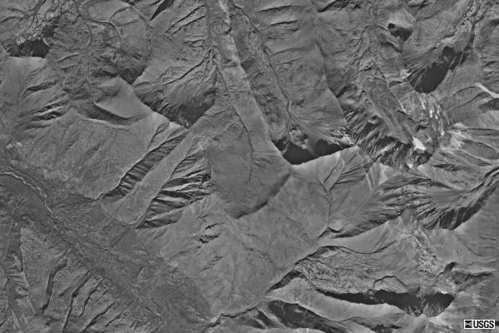
Straight channels in the mountains of Alaska

In contrast, meandering channels are most common and develop as rivers flow over relatively flat terrain where the gradient of the channel is low. Here, the river has no clear direction of flow due to the flat surface and as a result meanders across landscape, slowly moving a fine-grained sediment load downstream. The channels widen in relation to headwater streams allowing in more sunlight. In some cases like the American southwest, geologic forces have uplifted and tilted previously flat landscapes, creating steep gradients. Geologically rapid erosion in response to the uplift has preserved the meanders in deep canyons. The canyon walls are composed of hard rocks that resist erosion, so the river cut downwards, rather than straightening out the channel morphology. These steep gradient meanders, called entrenched meanders, have the capacity to carry large amounts of sediment.

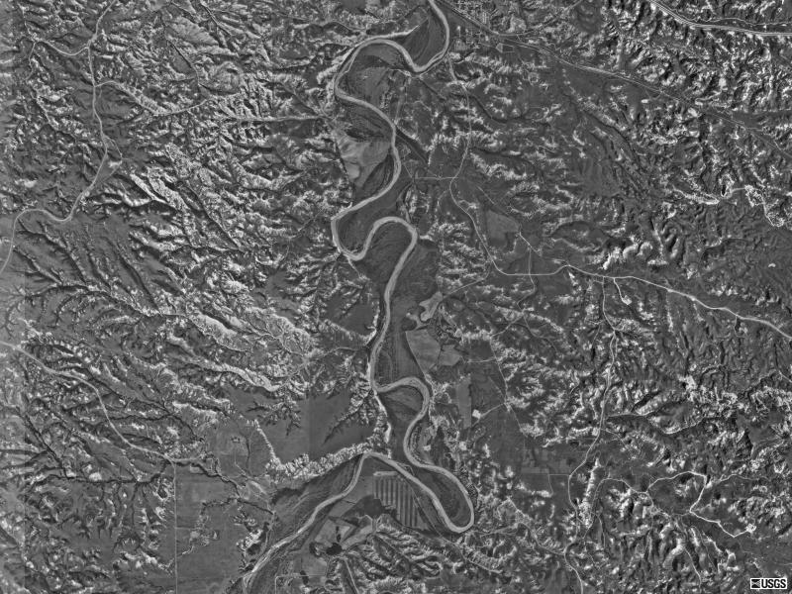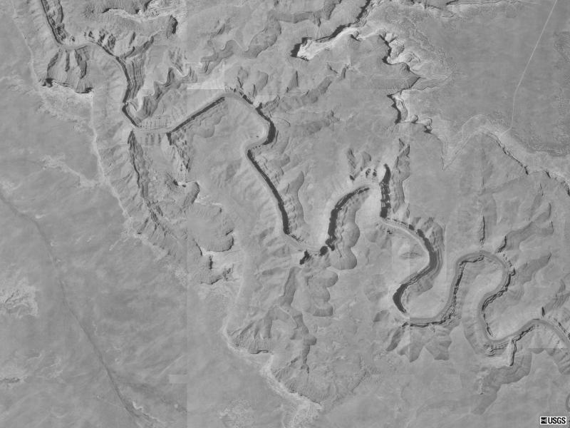
Meandering Missouri River, western North Dakota Entrenched meanders, San Juan River, Utah

Lastly, braided channels develop where the sediment available for transport is too much for the river to carry. This sediment builds up and the river channel divides, wandering over the deposited sediment in several narrower “braided” channels. These conditions commonly occur at the terminus of a glacier where melt-water runoff carries away enormous amounts of glacially eroded sediment.

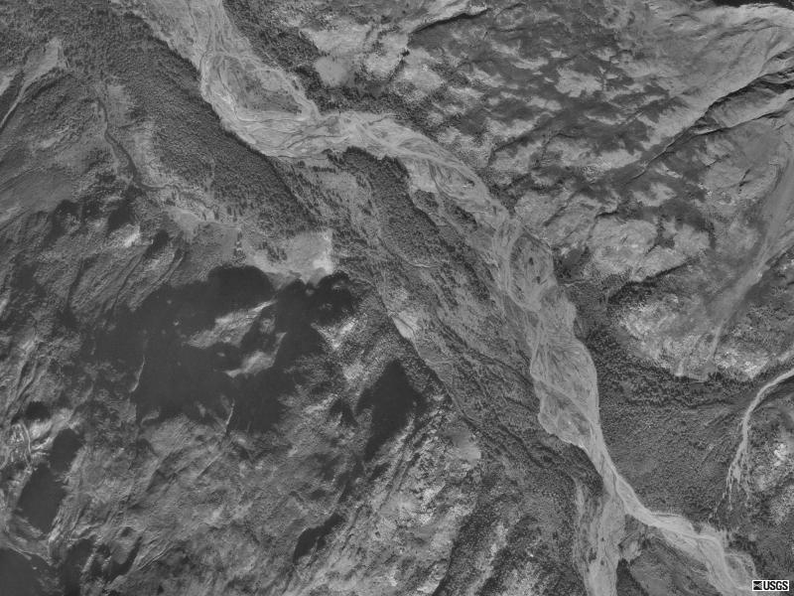
Braided glacial outwash channel near Anchorage, Alaska

At a smaller scale, channel morphology varies in response to flow patterns within each of the major morphology types. These dynamic flow patterns create distinct features along a channel, including cut-banks, point bars, channel bars, and knickpoints. Erosion and deposition of sediment varies at each of these points creating numerous unique habitats for aquatic organisms. At meanders, erosion occurs on the outside of the bend below the cut-bank because the flow of the water is highest as it pushes up along the channel wall. Along the inside of the meander, flow velocity is slower causing the river to drop, or deposit, sediment creating a point bar. Channel bars form as large grain sediments are deposited due to changing flow conditions in the center of the channel. Knickpoints are small steps that form perpendicular to the channel for several reasons including changes in the sediment load and transitions from resistant bedrock to softer rock. These steps in the channel gradient, sometimes forming waterfalls, generally migrate upstream over time and can provide pool habitat for aquatic organisms.

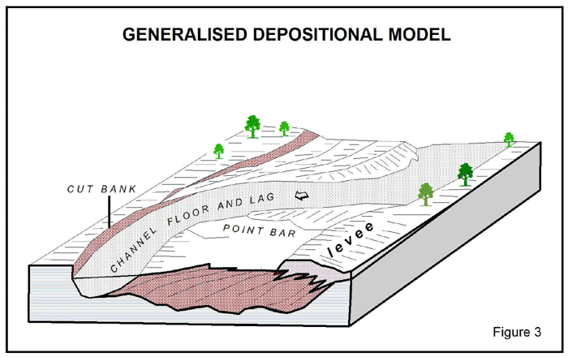
www.omegacorplimited.com.au/ projects.html

Procedure:
- Download aerial photos of Beaver Creek from: <http://www.mpcer.nau.edu/beavercreek/>
- Identify different channel morphologies along the watershed
- Using <http://terraserver-usa.com> zoom out and identify where the channel morphology changes as Beaver Creek meets the Verde River. Continue down the watershed to the Salt and Gila rivers.
- Based on the information given and the morphologies observed, hypothesize what causes the changes in channel morphology along this arid watershed.

Assessment:
- Go to <http://terraserver-usa.com> and find aerial photos rivers that fit into each of the river morphology types.
  - Straight channel
  - Meandering channel
  - Entrenched meander
  - Braided channel
- Describe the physical conditions that must be present for each morphology type to exist.

Field Research
Calculating flood discharge

Student Outcomes:
Students will:
- Generate hypotheses based on observations in the field
- Identify, measure, and calculate the channel bankfull parameters
- Measure and calculate channel gradient
- Calculate flood discharge
  - flood plain width
  - channel bottom width
  - channel gradient
  - high water/debris marks the edge of flood; trace to banks
  - Manning’s equation for trapezoidal channel (use formula in excel)
- Compare calculated flood discharge with documented annual max flood discharge

Inquiry:
- Guided observations and questions significant to the main research question:
  - What type of channel morphology defines Beaver Creek in this area?
  - Are point bars, channel bars, cut banks, and knickpoints present along the channel?
  - Is there evidence of large floods that could alter the physical component?
  - Are there abandoned and/or high water channels that provide empirical evidence for physical changes in the system?
  - What was the height of the last flood?
  - Could the level and discharge of the last floods move the channel? And, what sediment size could the floods have transported?
  - Is there evidence for areas of erosion and deposition?
  - Where does Beaver Creek fit in the River Continuum Concept based on its physical properties?
- Hypothesize
  - What is the potential for changes in the physical conditions in the measured reach of Beaver Creek?
- Test
  - Calculate flood discharge using Manning’s equation
  - Compare results to USGS discharge records

Materials:
- Clinometers
- students’ eye heights
- 50m tapes
- scientific calculator
- Sediment transport table:
Sediment Type | Sed Size | Velocity to Erode  and Transport
Fine sand | 1/8 - 1/2 mm | 0.82 ft/sec
Coarse sand | 1/2 - 1 mm | 1.00 ft/sec
Very coarse sand | 1 - 2 mm | 1.15 ft/sec
Granules | 2 - 4 mm | 1.64 ft/sec
Pebbles | 4 - 8 mm | 2.62 ft/sec
Cobbles - Boulders | > 8 mm | > 6.56 ft/sec

- USGS annual peak discharge records
http://waterdata.usgs.gov/usa/nwis/uv?site_no=09505200
  Water  Year | Date | Gage  Height  (feet) | Stream-  flow  (cfs)
  1962 | Feb. 12, 1962 | 8.50 | 1,870
  1963 | Aug. 27, 1963 | 6.87 | 748
  1964 | Aug. 06, 1964 | 9.40 | 2,030
  1965 | Jan. 06, 1965 | 11.58 | 6,100
  1966 | Nov. 25, 1965 | 11.62 | 6,150
  1967 | Jul. 31, 1967 | 10.52 | 4,340
  1968 | Mar. 10, 1968 | 6.80 | 982
  1969 | Jan. 25, 1969 | 9.84 | 3,500
  1970 | Sep. 05, 1970 | 12.41 | 7,670
  1971 | Sep. 01, 1971 | 9.24 | 2,890
  1972 | Jul. 16, 1972 | 10.25 | 4,020
  1973 | Oct. 19, 1972 | 11.32 | 5,490
  1974 | Mar. 18, 1974 | 4.47 | 119
  1975 | Apr. 13, 1975 | 6.97 | 1,060
  1976 | Feb. 09, 1976 | 11.95 | 6,880
  1977 | Apr. 07, 1977 | 4.71 | 155
  1978 | Mar. 01, 1978 | 10.46 | 4,360
  1979 | Dec. 18, 1978 | 12.38 | 7,560
  1980 | Feb. 19, 1980 | 13.96 | 10,900
  1981 | Apr. 05, 1981 | 5.49 | 368
  1982 | Mar. 12, 1982 | 12.05 | 6,880
  1983 | Nov. 30, 1982 | 11.32 | 5,480
  Water  Year | Date | Gage  Height  (feet) | Stream-  flow  (cfs)
  1984 | Dec. 27, 1983 | 9.10 | 2,740
  1985 | Dec. 27, 1984 | 10.20 | 3,960
  1986 | Feb. 18, 1986 | 6.39 | 710
  1987 | Mar. 18, 1987 | 7.20 | 1,180
  1988 | Feb. 03, 1988 | 10.15 | 3,900
  1989 | Mar. 29, 1989 | 5.24 | 285
  1990 | Sep. 05, 1990 | 6.78 | 922
  1991 | Mar. 01, 1991 | 9.38 | 3,030
  1992 | Aug. 23, 1992 | 11.16 | 5,280
  1993 | Jan. 08, 1993 | 17.21 | 16,000
  1994 | Mar. 20, 1994 | 5.63 | 405
  1995 | Feb. 14, 1995 | 12.53 | 7,330
  1996 | Aug. 02, 1996 | 6.53 | 1,050
  1997 | Apr. 08, 1997 | 5.77 | 596
  1998 | Mar. 28, 1998 | 8.34 | 2,500
  1999 | Jul. 27, 1999 | 10.49 | 4,460
  2000 | Mar. 29, 2000 | 4.73 | 195
  2001 | Aug. 04, 2001 | 6.94 | 1,310
  2002 | Sep. 10, 2002 | 9.77 | 3,590
  2003 | Mar. 16, 2003 | 9.05 | 2,930
  2004 | Sep. 19, 2004 | 7.32 | 1,630
  2005 | Dec. 29, 2004 | 11.58 | 5,670

Procedure:
- Observe site and hypothesize answers to questions significant to the main research question
- Identify high water level by recording the height of flood debris along the flood plain. Identify channel bankfull extent by abrupt change in bank slope (not including the flood plain)
  - Measure bankfull width, channel bottom width, channel depth, and channel slope lengths in meters but convert to feet for Manning’s equation. 1 meter = 3.28 feet (see diagram below)
- Measure average channel gradient or slope with eye heights and clinometers at three locations along study site
  - Two student stand within the channel anywhere between 25 and 50 meters apart.
  - Using the clinometer and eye heights measure the angle of slope between both ends of the measured distance or run.
  - Determine the tangent of the slope angle to get the slope value for the Manning’s equation. (tan Aº = opp/adj = rise/run) 100 times the slope value will give you percent slope, but use the slope value in Manning’s equation.
  - Repeat the slope calculation several times in different locations to get an average channel slope.
- Calculate flood discharge using Manning’s equation for a trapezoidal channel
- Compare calculated flood discharge with USGS annual maximum flood discharge. Remember, you just measured the bankfull, not the entire flood height and width which includes the flood plain.

